The English Dominican Congregation

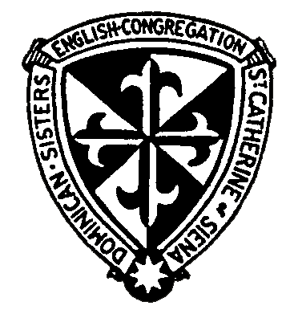
St Dominic’s Convent
Station Road
Stone
Staffs
ST15 8EN

14.07.2023

On behalf of all the sisters I would like to thank you all for coming today, in many different ways you have supported the sisters here in Stone over the years.

I would particularly thank His Grace the Archbishop for finding time in his busy schedule to come and celebrate this Thanksgiving Mass and for all his support since I first went to discuss the closure of the convent with him.

Many Dominican Provincials have also supported us providing chaplains and continual help and advice and Martin, the present Provincial has always been there for us and we were delighted that he could be here for us today, it was fitting in this Church that a Dominican friar preached the homily.

The congregation gave this Church to the diocese in 1971 and no-one could have imagined then that just over 50 years later we would be preparing to leave this convent. Many sisters were working in both schools and St Mary’s as well as many other apostolates and the convent was full.

The earliest sisters were among the pioneers in the living of Dominican community life and their first Constitutions formed the basis for many other congregations both in England and overseas. This week I had an email from America sending us good wishes and saying the very name of Stone evoked deep gratitude in the hearts of so many Dominican sisters for the enduring legacy of our Constitutions.

There have been many wonderful ladies here over the years including the small band recently who have struggled to live in such a huge building and faithfully maintaining the Dominican life of prayer, study, community life and preaching.

However, times change and we must accept that challenge as Dominicans have done since the time of St Dominic and the convent is now simply too large for us and we cannot afford to maintain it.

My predecessor spent years deciding what development would be most suitable bearing in mind the proximity of the Church, the schools and St Mary’s. Much advice was sought including from the diocese and beyond and a senior living development seemed to be the most suitable and possible in a listed building. Hopefully that will go ahead in the not too distant future but contracts still need to be signed.

We are not selling Blessed Dominic’s chapel and when the construction work begins in the grounds will refurbish it to provide a fitting pilgrimage site when Blessed Dominic Barberi is canonized. I know the canonization of Blessed Dominic is a fervent prayer of His Grace – but if he could give us a couple of years to make it a beautiful, safe chapel that would really help!

The sisters’ cemetery will also remain our property where we will continue to venerate the great sisters who have lived here.

It is a sad time for us as well as a challenge we have grasped, most of us made our final vows here and many have lived here and Stone will always remain a very special place for us. Two sisters are remaining and plan to live locally and help in the parish so you will still see Sisters around.

The congregation remains optimistic about the future as we face different challenges but we do thank you all so very much for all your help and support and please keep us in your prayers.

Sister Mary Teresa,o.p.

