MAKING A REGULAR SCAPULAR (6 cm x 7.5 cm)

Material:
- 50/50 wool/polyester blend, white in colour (best to use remains from the making of friars’ habits)
- 100% cotton tape 20mm wide
- White and dark (black) thread

Do not worry if your scapular comes out a bit wonky. It isn’t a fashion statement. I don’t have a sewing machine, so this is based on hand sewing using a back stitch (according to YouTube https://www.youtube.com/watch?v=qkNX9UKmSLE). Warning: I am not an expert at sewing!
Try to trace out your pattern on the cloth with right-angled corners as best you can and cut out. I use a ruler and a protractor to achieve the right angles.

Dimensions: 10.5 cm by 15 cm
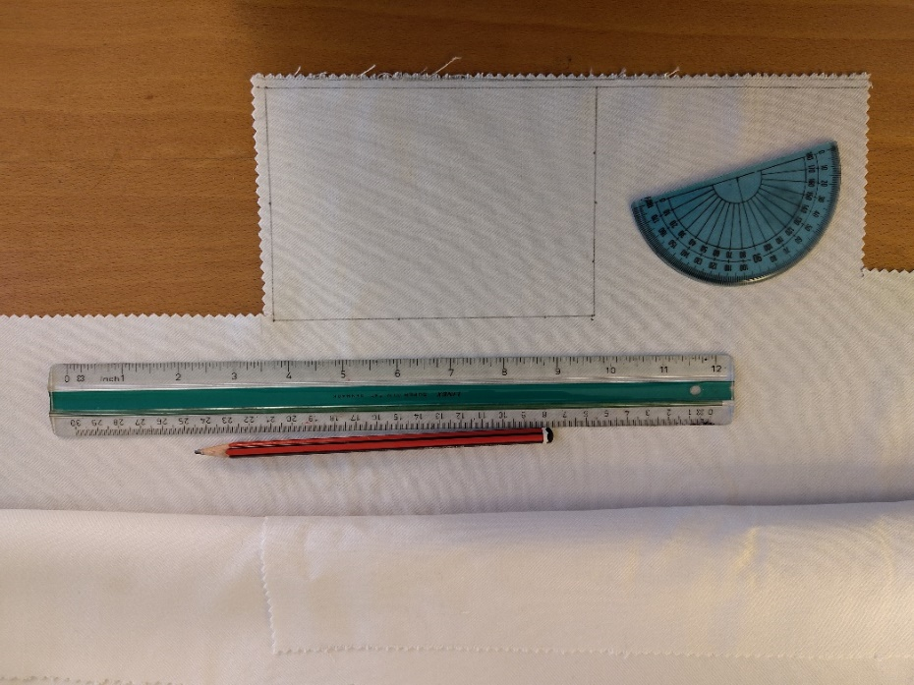

Pinking shears help to prevent the edges from unravelling. Cut close but not on the pattern you drew.
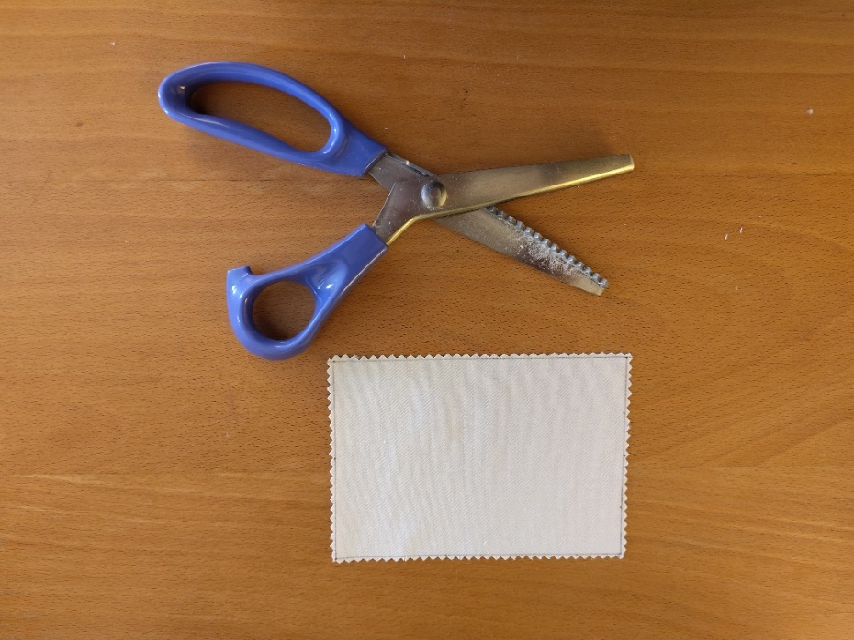

Cut out another similar piece so you have two rectangles for your scapular.

Draw in your stitching lines (solid) about 1 cm from the margin along the bottom and sides; and your folding line (dashed) about 1.5 cm from the top on both pieces of cloth.

Fold each piece in half and iron on a low (wool) setting.

Pin securely the bottom and side of each piece.
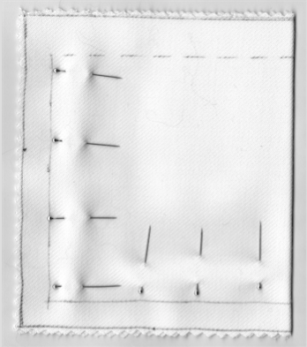

Backstitch along the solid stitch-line making sure both sides are aligned.

Turn the pockets inside-out and gently push out the corners (I use a manicure stick). Iron them flat.
Mark out the fold line with pins by pushing the pin from the outside through the dash fold line inside the top of the pocket and then push the pin further along the fold line back outside. Once marked out, fold over into the pocket so the pins are on top. This could be tricky around the pocket seam. Just push the seam to one side and fold over. Pin the fold in place.
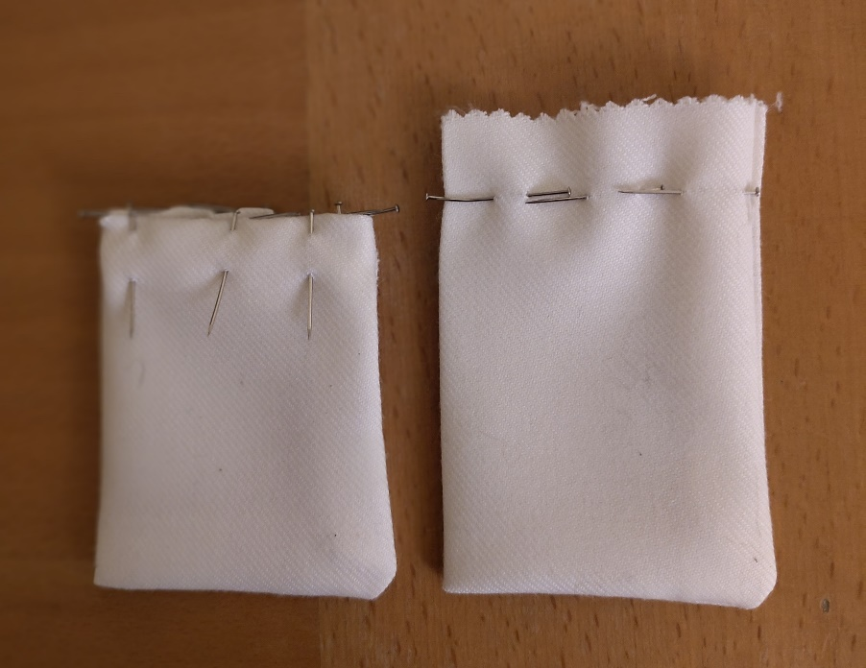

Use a basting stitch in black or any dark thread to secure the fold in place.
Remove pins and iron out flat at a low (wool) setting.
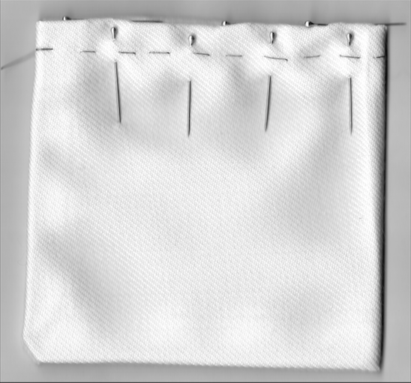

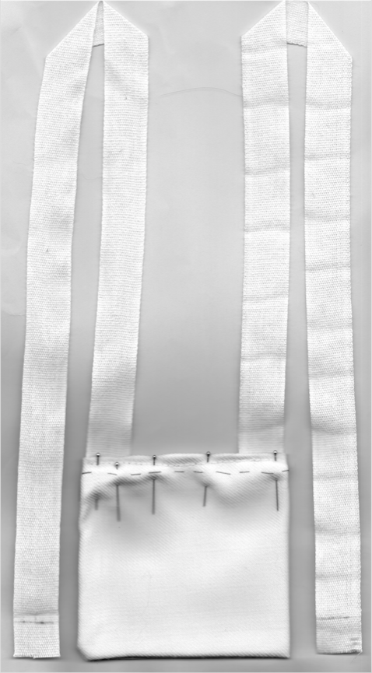
Measure out 2 lengths of cotton tape 51 cm each.

Mark off 1.5 cm at each end of each length of tape.

Insert one end of each tape into a pocket. Pin in place and stitch the pocket close (be careful of doing neat stitching on both sides and start from the inside lip of the pouch so the knot and loose ends are hidden. I use the manicure stick to push the loose ends into the pouch to hide them).

Remove pins and basting stitch and that makes one-half of your scapular.

Insert the other ends of the tapes into the second pocket (be careful that the tape isn’t twisted). Pin in place and stitch the pocket close.

Iron the pockets and tape again.

Et voila! Another scapular has been created. What this world needs is more scapulars!
