|  |
| --- |
|  |
| Lay Dominicans English Province  Annual Report 2024/25 |
| |  |  |  | | --- | --- | --- | | Margaret Doyle |  | September 2025 | |

# Introduction

This report covers a year of further growth and development of the Lay Dominican presence in our province, with the establishment of 3 new Fraternal Groups and the celebration of many new admissions and professions.

As always, we have been celebrating links across the Dominican family, and this year included a visit from the Master of the Order, as well as our regular events such as the Seminar in Leeds and the pilgrimage to Walsingham.

The report itself gives an overview of the life of the Province, and there are 2 Appendices:

A: Formation Report

B: Treasurer’s report

If you have any questions or comments about the information in this report, please get in touch.

In St. Dominic,

Margaret Doyle

Lay Provincial President

Email: [margaretdoyle1066@sky.com](mailto:margaretdoyle1066@sky.com)

|  |  |  |
| --- | --- | --- |
| Lay Provincial Council | | |
| Margaret Doyle | President | North East |
| Fernando Cervantes | Vice-President | Bristol |
| Gigi Horsfield | Secretary | Oxford |
| Philip Owens | Treasurer | Oxford |
| Andy Doyle | Directory Review | North East |
| Teresa Jankowska | Communications | Oxford |
| Sara Parvis | Formation | Edinburgh |
| Catherine Wallis-Hughes | Events | London |
|  |  |  |
| Fr. Thomas Therese Mannion OP | Provincial Promoter of the Laity | |
| Sr. Rose Rolling OP | Representing the sisters | |

# Our Fraternities and Fraternal Groups

# 

We now have 14 Fraternities or groups. 5 of them are next to a house of friars and 2 next to houses of sisters. For the other 7, the Lay Dominicans are the only Dominican presence in their area.

**Our new groups**

* **Glasgow:** a new Fraternal Group was set up in Glasgow in October 2024. Before then, Edinburgh was our only Fraternity in Scotland, and in the last couple of years a number of those professed and those enquiring were from the Glasgow area. The new group was inaugurated during the visit of the Master to Edinburgh in October 2024.
* **Lymington**: the group at Lymington have been meeting with the support of the Dominican Sisters of St. Joseph. In August 2025, there was a celebration Mass, as the Fraternal Group was formally inaugurated. With 6 professed members, 2 admitted and a number of enquirers, the group continues to grow.
* **Yorkshire**: the group meets in Leeds and was set up by 2 professed Lay Dominicans who moved to the area. They have now been joined by 2 more people (1 admitted and 1 temporarily professed) and the group was formally inaugurated in August 2025.

# Lay Dominicans: Numbers

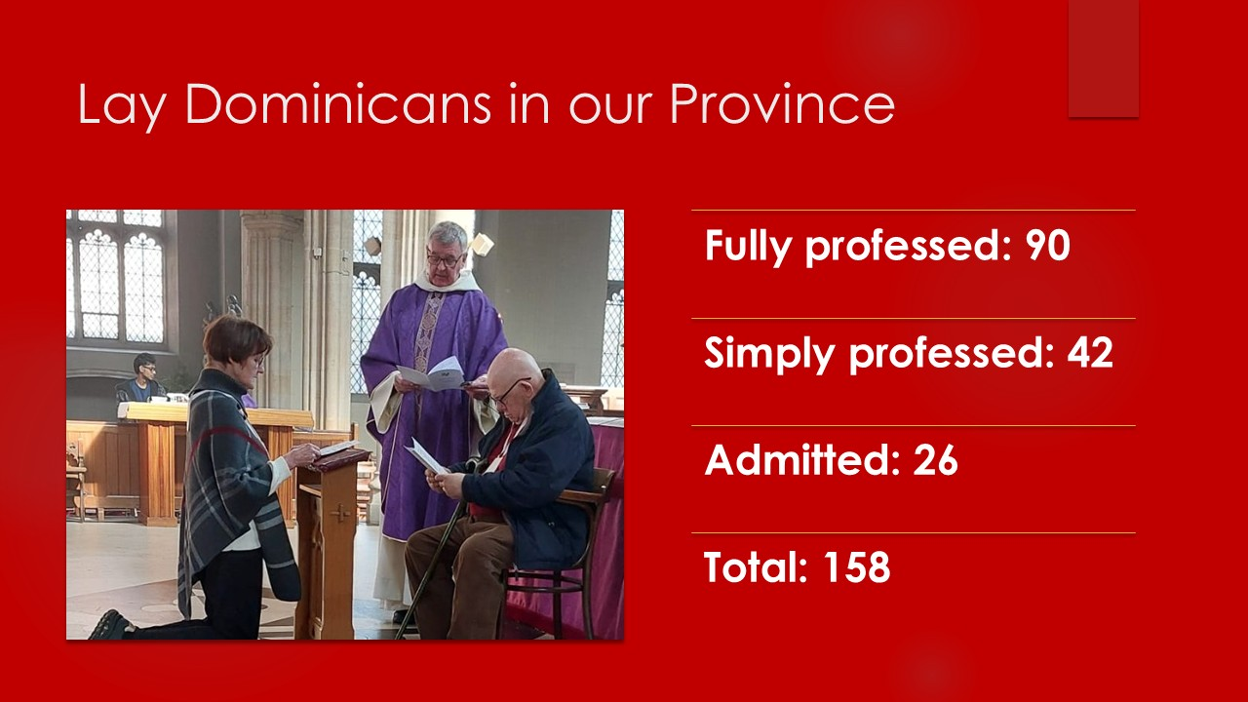

2 people who had been admitted chose not to make profession, and 3 people who had been temporarily professed chose not to make perpetual profession. In addition, 2 people moved away and transferred to other provinces, one to Ireland, and one to Italy.

During the year we also celebrated with:

* Margaret Grant (Lymington) who celebrated her 100th birthday with a letter from the Master of the Order, fr. Gerard, as well as a card from the King and Queen, and
* Jonathan Wright (Cambridge) who was ordained to the Permanent Diaconate for the Diocese of East Anglia.

We have also lost some of our brothers and sisters this year. May they rest in peace.

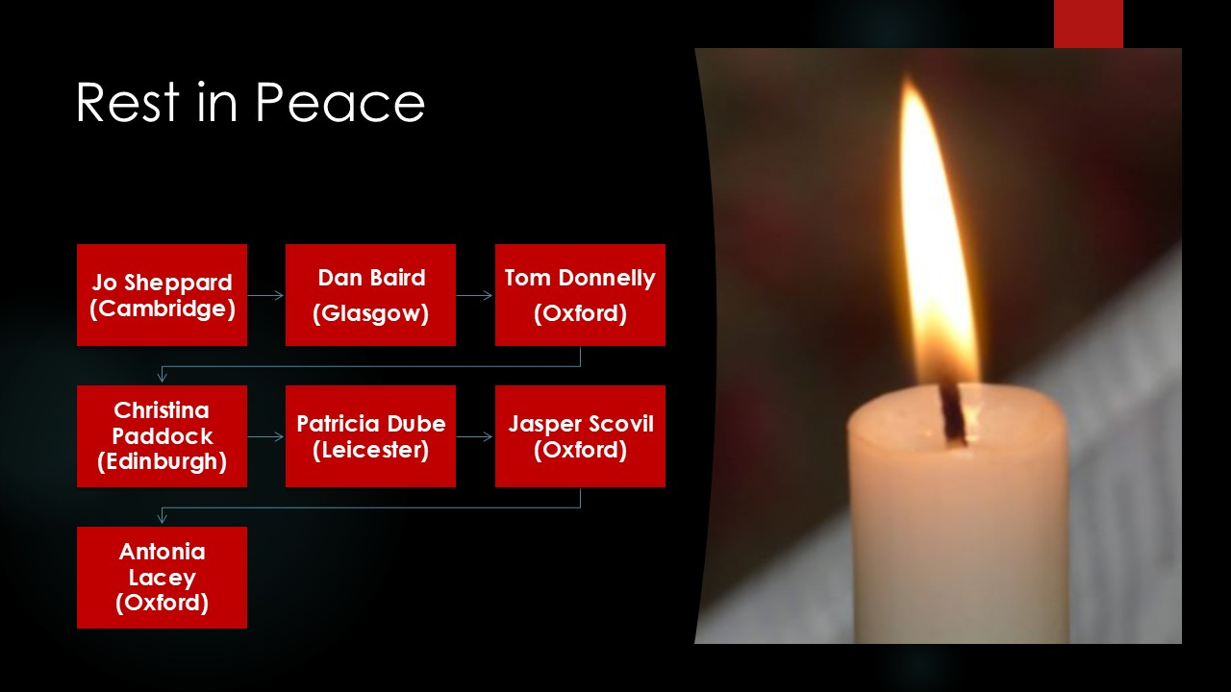

# The Master of the Order

Fr. Gerard Timoner OP, the Master of the Order, visited the Province in October 2024. He travelled throughout the province and met the Lay Dominicans at each site.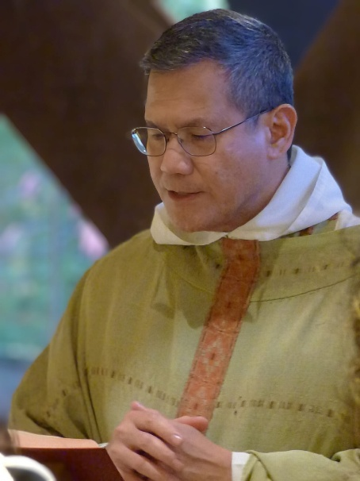

While he was in Edinburgh, he was present at admissions and professions into the Edinburgh fraternity, and at the inauguration of the Glasgow Fraternal Group.

In London, there was a Mass at the Rosary Shrine for the whole Dominican family, followed by a reception in the parish hall. Fr. Gerard then met with the Lay Provincial Council, and we updated him about the life of the Lay Dominicans in the Province, and gave him copies of last year’s annual report and of our contribution to the Synod on Synodality, which we sent to the Bishops’ Conferences last year. The Master then asked us to get in touch with fr. Cristobal, the Promoter General of the Laity, and we have invited him as the guest speaker for this year’s Assembly.

# Events

It has been a very busy year for events, many of them organised by individual fraternities, but advertised more widely so that others can attend:

* At our Annual Assembly in September 2024, our main speaker was fr. Nicholas Crowe OP, the Prior Provincial. He spoke about ‘Communication, Communion and Community’.
* ‘Sing Like a Dominican’: an event organised by Bristol fraternity, was facilitated by fr. Matthew Jarvis OP, and gave those attending an introduction to Dominican chant.
* The Day of Reflection for Advent in Crawley was entitled ‘A Light from the Shadows Shall Spring’, and fr. Thomas Mannion OP looked talked about the fulfilment of the Old Testament and the Lord of the Rings.
* North East celebrated the Feast of St. Dominic with a pilgrimage to the shrine of Our Lady of Jesmond, Vespers at St. Dominic’s church in Newcastle and dinner at Blackfriars restaurant, in the buildings of the Medieval Dominican house.

# Other initiatives

* Cambridge Fraternity recorded a play called ‘Scenes from the Life of St. Dominic’, written by Hilary Pepler in 1929.
* Sara, our Formation Officer, is working with the Fraternities and groups to produce a series of videos on a variety of subjects, to supplement the formation which takes place locally.
* We provided links and resources to assist people in the debate about Assisted Suicide, to support them in writing to MPs and answering questions from friends and colleagues.

# Record Keeping

Last year we reported on the work to get a better record of the Lay Dominicans in the Province. Many thanks to Gigi, the secretary, and to all those in our groups who have worked to update our records. Although not perfect, they are a lot better!

Last year we reported 2 specific issues:

* *We do not currently have a clear reporting process for Fraternities when someone who has been admitted decides not to go forward to profession, or when someone who has made first profession decides not to make final profession.* This has now been addressed by the implementation of an annual return from fraternities, in the form of a template which will provide that information. This one template will allow us to update the database each year, and will also be used to provide figures for other purposes, such as the calculation of the levy, the figures for this annual report and the number of delegates expected at a chapter.
* *We are aware of a number of people who have decided to ‘leave’. When someone has made their final profession, they are Lay Dominicans for life unless they have a dispensation from the Prior Provincial, but this has not always been done.* This issue will be addressed as part of the discussion on Community at the chapter in 2026 (see p. 9 )

# Finance

The annual statement and update from our Treasurer, Philip, are attached separately.

During the year, we also held a call for Presidents and Treasurers of our groups to share their ideas and issues about finance in the groups, from how to set up a bank account to financing the expenses for Religious Assistants, room hire and any guest speakers.

# The Dominican Family in the English Province

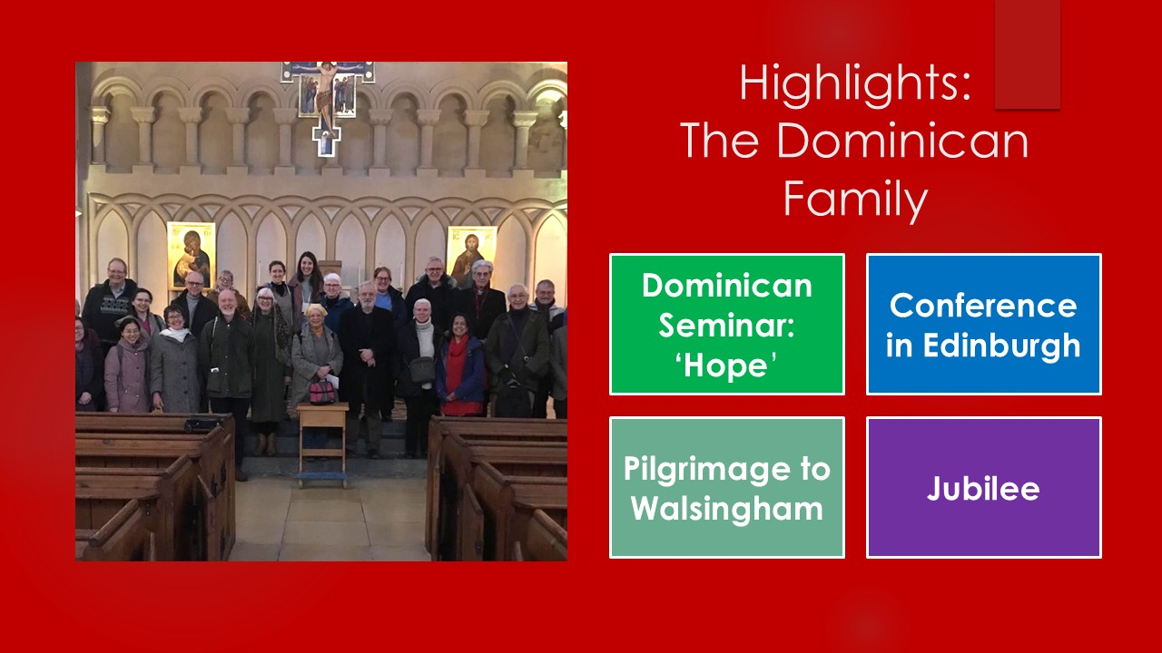

* The Dominican Seminar takes place annually at Hinsley Hall in Leeds, and this year’s theme was ‘Hope’ as part of the celebration of the Jubilee Year, with the theme ‘Pilgrims of Hope’. As always, there were several speakers, and Dr. Sara Parvis (Edinburgh) spoke about ‘A Church of Heroic Communities: Militant Hope’. Lilian Lee (also Edinburgh) spoke about Bl. Pier Giorgio Frassati, in advance of his canonisation in September 2025, and also on the Jubilee theme, Simon Hewitt (Yorkshire) spoke about Indulgences.
* Many Lay Dominicans travelled to Edinburgh in June for the Conference organised by the friars in Edinburgh, Lay Dominicans travelled to Rome with the Dominican Young Adults Group for the Jubilee of Young People, and several Lay Dominicans travelled to Spain in September 2024 for a pilgrimage led by fr. John Farrell OP.
* The pilgrimage to Walsingham has been a regular event for many years and Lay Dominicans from many of our groups joined the pilgrimage.

# Contact with Lay Dominicans elsewhere

A group of us from the Lay Provincial Council have regular Zoom meetings with the Provincial Councils from the Irish province and the Province of Australia, New Zealand and Papua New Guinea. It is good to share the issues we are working on – in Australia, a large group of Lay Dominicans from the Vietnamese communities who previously had their own structures have now been incorporated into the Province – and their numbers have therefore risen from 150 to 700!

# Communications

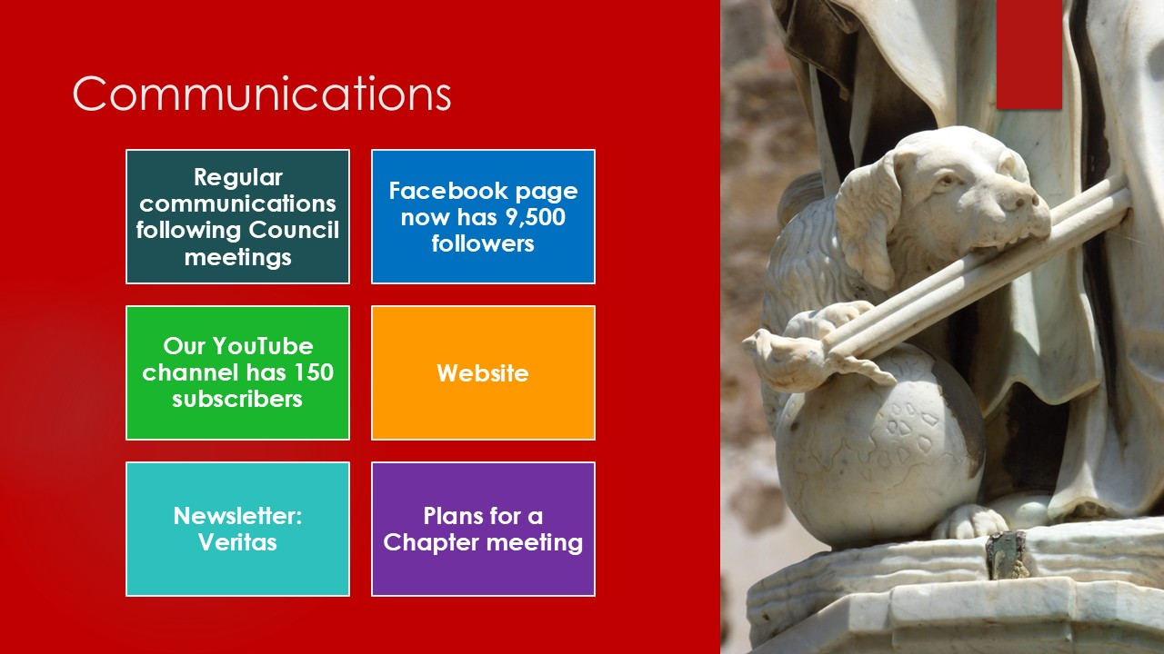

Our regular updates from the Provincial Council now go out as a Word document / newsletter so that it is easier for Presidents to forward on to people by email, or to print and give out at their monthly meetings. This has been well received.

Veritas, the Province’s newsletter, continues to be published by Teresa, our Communications Officer. Veritas appears a couple of times a year and Teresa is always happy to receive news from Fraternities and articles and reflections from the Lay Dominicans of the Province.

We continue to build the content on the website. It carries news from Fraternities, particularly of admissions and professions, and information about each Fraternity, but we also have an ever-increasing library of reference documents, resources and reflections. We use Facebook to highlight news stories we have put on the website and also to share news stories from elsewhere in the Dominican family. Our YouTube channel shares some of the talks from the Assembly and the Seminar with those who were unable to attend, and we have plans for making formation material available on YouTube too.

Please let us know if there is more we can do to improve communications – or indeed if you have news stories or reflections to share.

# Looking ahead: Chapter 2026

Over the last few years we have been working hard to get good communication across the province. And at our AGMs and the on-line Synod meetings we held, we have found that people have plenty to say! At the Provincial Council meeting we have been talking about the need to allow more time and opportunity for people from all our groups to contribute to discussion on some really important subjects, and the limited time we have available at the AGM does not give us enough time to hear from everyone.

So we are planning a Chapter meeting in June / July 2026, to allow us the time for better consultation on a number of subjects. We already have a chapter meeting - an elective chapter, every 4 years to elect the Lay Provincial Council.  What we are proposing is a separate chapter to discuss issues that are important to the Province. We have identified 3 key subjects:

* Community
* Mission
* The Directory

We are about to start work on all 3 strands so that there is the opportunity for everyone to contribute views and thoughts, in advance of the Chapter meeting itself, which will be attended by delegates from all our groups.

[*www.laydominicans.org.uk*](http://www.laydominicans.org.uk)

*email: laydominicansuk@gmail.com*

# Appendix A: Lay Dominican Provincial Council Formation Report Oct 2024- Sep 2025

**Dr Sara Parvis, Provincial Formation Officer**

**The Mission of the Provincial Formation Officer (Directory 39)**

39 a) The Formation Officer presents the Council with the formation programme that has been worked out in cooperation with the promoter.

b) He or she promotes this programme in consultation with the Formation Officers of the Fraternities.

**Introduction**

This is my third of four annual reports to the Provincial Assembly as Provincial Formation Officer for the Lay Dominican Provincial Council of Oct 2022-Oct 2026. As there have now been two different approaches to Formation policy in this term, and there is about to be another one, it seems sensible to summarise my work as Provincial Formation Officer to date, before outlining the new direction that Lay Dominican Formation Policy now needs to take.

**Stage 1 (Nov 2022- March 2024): Formation Zooms and summary Formation document**

When I became Provincial Formation Officer in November 2022, Fr John Farrell OP was Provincial Promoter of Lay Dominicans. The extensive existing Formation programme agreed by the previous Council had only recently been completed, and in his view, no further work needed to be done on it for the time being. It was (and is) available on Dropbox for the use of all the Formation Officers of the Fraternities. It was agreed, therefore, that I would simply prepare a summary of what needed to be covered in initial formation, agree that with Fr John and the Lay Dominican Provincial Council, and circulate that to all the Formation Officers, which I did. I also scanned and added to the Dropbox the previous materials prepared with Fr Richard Conrad, which some Fraternities still use, and which also contain useful bibliographies. In addition, I set up a series of Formation Zoom meetings, to consult with the Formation Officers of the different fraternities and engage with the wider formation needs of the Province.

**Stage 2 (April 2024- present): Schedule of Supplementary Formation materials**

In April 2024, Fr John’s second term as Provincial Promoter was completed, and Fr Thomas Mannion was appointed the new Provincial Promoter of Lay Dominicans by the friars’ Provincial Chapter. After consultation, he and I agreed that further work now needed to be done on the Formation Programme, because some of the original links no longer worked, and the materials they linked to were either not available at all, or hidden behind paywalls. In addition, further consultation by Zoom with the Fraternities’ Formation Officers confirmed that the Lay Dominican Formation needs in the Province were very diverse. Some groups had well-developed programmes of their own which were meeting their needs well, alongside the existing Dropbox materials. Others were struggling to some extent, or unsure how to proceed.

In order to strike a balance between supporting Fraternities and Fraternal Groups who were struggling to develop and deliver effective formation programmes, while recognising the existing expertise of Formation Officers and their groups who were confident and experienced in delivering existing programmes, we developed, with the Provincial Council’s agreement, a new approach. Each Fraternity would contribute a supplementary video or audio recording, which would be made available via Lay Dominican private Youtube channel, on one of the core Formation topics: Scripture, Theology, Liturgical Prayer, the History and Tradition of the Dominican Order, Contemporary Documents of the Church and the Order, and the Signs of the Times. The sessions could be watched by members of a formation group individually beforehand and then discussed in a formation session, or given to an individual to watch or listen to alone, or be shown to a whole group at once and then discussed.

In order to expedite the process, I arbitrarily assigned topics to all the Fraternities and Fraternal Groups, on the understanding that they could change topic if they wished, as long as they consulted on their new choice. This list of topics was circulated at the Last Assembly Day, in September 2024. Since then, we have had one Zoom meeting, at which a number of Fraternities asked if they could change topic. We confirmed that Fraternities are very welcome to choose their own topics as long as they consult with us before changing.

So far, the only recording which is complete is that of the Edinburgh Fraternity, a voiced powerpoint on the **History of the First Lay Dominican Rule**, written and narrated by Dr Paul Parvis. This is available to all Formation Officers via Dropbox. The North-East Fraternity, which is responsible for an overview of the **Documents of Vatican II**, is in the course of preparing theirs, as is the North-West Fraternal Group, which is preparing **Signs of the Times III: Science and Religion**.

**Stage 3 (From August 2025): Incorporation of the new *Ratio Formationis et Studiorum*.**

Fr. Gerard Francisco Timoner III, Master of the Order, formally approved a new Lay Dominican Formation document on July 16, 2025, our first ever ***Ratio Formationis et Studiorum***. It is available on our Lay Dominican Provincial website under Resources: [Ratio Formationis et Studiorum Laicorum – LaiciOP](https://laici.op.org/2025/ratio-formationis-et-studiorum-laicorum/). This substantial document will need to be discussed and digested at Provincial level before we can begin to apply its recommendations more locally, and this process is unlikely to be completed in the current Provincial Council’s term of office. However, Fr Thomas, Margaret and I intend to hold a Formation Zoom meeting with all the Formation Officers soon after the Assembly Day to discuss how best to begin to implement the document in the short, medium and long term. Margaret will be circulating dates for this shortly, to avoid clashes with the already-planned Zoom meetings scheduled in preparation for our own Chapter next summer. It should be a reasonably straightforward matter, however, to harmonise the new list of recommended topics with the existing list of formation topics due to be written and recorded this year by the Fraternities, and to draw on the Province’s existing theological and historical expertise.

# Appendix B: Treasurer's Report for the Lay Dominicans in the Province of England from 1st September 2024 to 31st August 2025

**Introduction**

There are two bank accounts, both with HSBC, in the name Dominican Laity: -

* the main account, number 91177869, sort code 40-10-14 and
* the secondary account, number 91177877, sort code 40-10-14.

Together they hold a total of **£17850.78** which constitutes our general funds plus **£12427.03,** the current value of the Barbara Knight Fund intended for extraordinary expenses. Please note that the Barbara Knight Fund was originally established with a donation in the name of Barbara Knight to the value of £15003.75. The Provincial Council have voted to use this remaining sum to finance the proposed Provincial Chapter next year. It will be up to those at the Chapter to determine whether to replace this amount and how future chapters will be financed.

While I have been treasurer, I have been putting to one side money from the Annual Levies to meet our obligations to the European and International Lay Dominican Councils. I was told to collect £2 per person per annum for each professed Lay Dominican. Since, however, I was never contacted about these contributions and there seemed to be confusion on the precise sums involved I simply put the monies to one side. This money was recorded in my reports as leaving the general account of money available for us to spend but in fact remained in our account awaiting a specific request for it. I regarded it as no longer part of our general account. Since 2019 I had reserved a total of £2464 to meet both claims. This year I finally heard from Europe. It seems that their Treasurer, Bogdan Penev, has inherited a very difficult situation; the actual agreed levy per person is 1.50 Euros although he is seeking, with good cause, to double this. I calculated we should pay £647.30 up to the end of 2024 starting from 2022 as requested and learned that this would cost us £30 to transfer. I paid this on our behalf. I have heard nothing from the International Dominicans so I am still banking £1232 for them. This does however, mean that I have returned £554.70 to our general fund which is the difference between the sum I put to one side and the amount actually requested. Please note the sums of £122.67 designated for the ECLDF and ICLDF in the following report are the sterling equivalents of the 2025 levies. The ICLDF money will remain, for the moment, in our bank account.

The following report refers to transactions from this general fund, actual cash transactions into and out of the accounts and allocated amounts.

Please note that the sum raised by the levy this year is more than twice what was raised last year (£3257 compare with £1450) and indicates 131 professed Lay Dominicans rather than an incorrect 58 members suggested by last year’s figures. This clearly indicates that we have been more successful in collecting the levy. There still remains some inevitable uncertainty as to what constitutes lapsed Dominicans, and this will remain.

**Combined Balance as of 1st October 2024 was +£3696.79** and this is money available for us to use however we deem necessary.

**Transactions this year from the general account**

* Income from Annual Levy for 2024-5 +£3275.00
* Interest from the Bank +£55.61
* Profits from Dominican Memorabilia +£183.00
* Bank Charges -£91.60
* Expenses paid to members of the Provincial Council -£1045.25
* Cost of Website £407.20
* Half cost of an annual Zoom licence (shared with the

Oxford Fraternity) -£51.96

* Levy due to ECLDF for 2025 (at 1.50 Euro per

Estimated. Number of professed members -£122.67

* Levy due to ICLDF for 2025 (at 1.50 Euro per

Estimated. Number of) professed member. -£122.67

* Money originally reserved for ECLDF now returned to general fund

+£554.70

* Loan to Dominican Association to finance a deposit for the

Dominican Seminar in 2027 which will be repaid in 2026 -£500.00

**Total +£1726.96**

Therefore, money in General Fund is…

* Money carried forward +£3696.79
* Money left after the current transactions +£1726.96

**Total** **+£5423.75**

So total funds available as of 1st September 2025 is…

* Money in Barbara Knight Fund +£12427.03
* Money in General Fund +£5423.75

**Total +£17850.78**